1st CALL FOR STSM FOR AID-AgE CA24147 COST ACTION

Introduction
Short Term Scientific Mission (STSM) is a grant that allows Researchers or Innovators to visit a host organization located in a different country than the country of their affiliation, for the specific work to be carried out and for a determined period. We have an Open Call for STSM Grants using a rolling system for the deadlines for STSM Grant Applications, which for this grant period are as follows:

Budget
A total of 26.000 EUR is allocated to STMS in this GP. This amount may change depending on the needs of the action and the actual budget availability. All the applications will be evaluated within 15 days and the applicants will be informed about the decision. Up to 4000 EUR can be awarded for a STSM.
Only applications for future missions will be approved. Grants cannot be rewarded retroactively for scientific missions that have already taken place at the time of the cut-off date.
All STSMs need to be finished, and its report submitted maximum on the last day of the grant period (31/10/2026).

Eligibility criteria
Researchers and Innovators with appropriate affiliation as described in the Annotated Rules section 4.1.1.1.1. AFFILIATION.
Additionally, priority will be given to active Working Group members whose application is endorsed by the Working Group and whose STSM output is closely related to the goals and deliverables of the Action. For more information, please see the Memorandum of understanding.
Participation of Young Researchers/ Innovators (<40-year-old) in STSMs is encouraged. In the evaluation of two applications with the same score, the one from a Young Researcher will be considered first.
The Table below (page 59 COST ANNOTATED RULES) describes all eligible scenarios. Applicants may receive only one STSM per Grant Period.
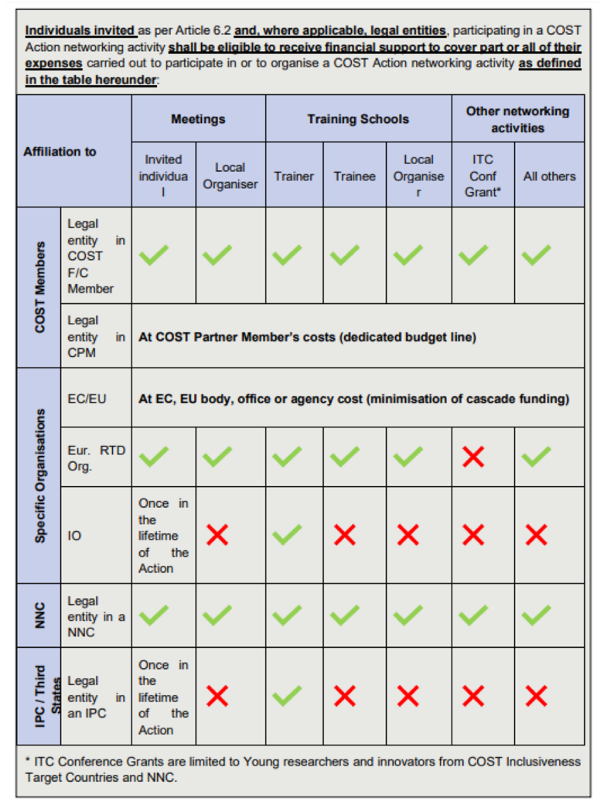
Evaluation criteria
All the applications will be evaluated based on the following criteria:
- 60% Appropriateness of the STSM for the selected Working Group and objectives.
- 20% Quality and feasibility of the work plan.
- 20% Quality and feasibility of the planned outcomes.
Evaluation board
- All applications will be evaluated by the GAC and the ACTION CHAIR, and the Grant letter will be sent by the GHM if there is sufficient money available in the Action’s Budget.
How to apply?
To apply for a STSM Grant within the Cost Action, please fill in the STSM application form available on the e-cost system and upload the following documents:
- Application form (template available on e-COST) describing: Goals, description of the work to be carried out by the applicant, expected outcomes and description of the contribution to the Action MoU objectives. Note that applications without clear contribution to the Action objectives will not be taken into consideration. Priority will be given to applications that are coordinated with the working groups.
- Confirmation of the host (invitation letter) on the agreement from the host institution in receiving the applicant.
Detailed instructions on how to apply for STSM can be found in COST’s official Grant Awarding User guide available HERE.
Information and documents to be provided by the grantee: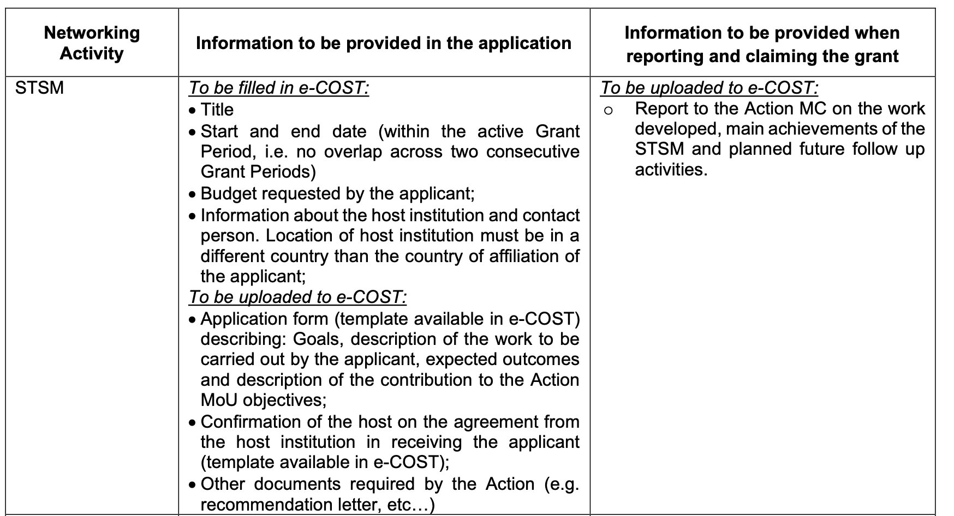
Financial support
AID-AgE CA24147 COST ACTION will decide on the financial contribution for each STSM, taking into consideration the budget request of the applicant, the outcome of the evaluation of the STSM application, the duration of the mobility, the location of the Host and the total number of STSM approved.
In calculating the requested financial contribution, applicants should take the following criteria into account:
- A fixed daily rate for accommodation and meal expenses, calculated according to the country daily rates approved by COST;
- A maximum of EUR 4,000 can be granted to for each successful applicant.
- The Evaluation board may decide to grant a different amount to that initially requested by the participant. ( e. g. The participant asks for 2.500 EUR, but the amount, after assessment, is adjusted to 2.000 EUR)
Recommended daily rates for calculation of travel grants for STSM: https://www.cost.eu/uploads/2024/11/2024-Daily-allowance-table.pdf

If you have any queries, contact the Action’s GAC XXXXXXX at XXXXXX

