1st CALL FOR VMG FOR AID-AgE CA24147 COST ACTION

Introduction
Virtual Mobility Grant (VMG) is a grant that allows financial support to foster collaboration in virtual settings. The aim is to strengthen existing networks by enabling individual researchers from one COST country to participate in research activities carried out in institutions in other COST countries, in order to foster collaboration and contribute to the scientific objectives of AID-AgE CA24147. Virtual mobility refers to activities that do not require physical travel but involve online collaboration, communication and knowledge sharing between researchers or participants of different countries.
The focus is on facilitating collaboration, sharing expertise and networking through virtual means such as videoconferencing and other digital platforms. We have an Open Call for Virtual Mobility Grants using a rolling system for the deadlines for VMG Applications, which for this grant period are as follows.
All VMs need to be finished, and its report submitted maximum on the last day of the grant period (31/10/2026).

Eligibility criteria
Researchers and Innovators with appropriate affiliation as described in the Annotated Rules section 4.1.1.1.1. AFFILIATION.

Evaluation criteria
All the applications will be evaluated based on the following criteria:
o 60% Appropriateness of the VMG for the selected Working Group and objectives.
o 20% Quality and feasibility of the work plan.
o 20% Quality and feasibility of the planned outcomes.

Evaluation board
All the applications will be evaluated by the GAC and the ACTION CHAIR, and approved by the GHM if there is sufficient money available in the Action’s Budget.
How to apply?
To apply for a VMG Grant please fill in the VMG application form available on the e-cost system and upload the following documents:
Application form (template available on e-COST) describing:
• Goals, description of the work to be carried out by the applicant
• Main objective of the VM
• Working plan
• Plan for participation and expected outcomes
• Description of the contribution to the Action MoU objectives and deliverable

Information and documents to be provided by the grantee:

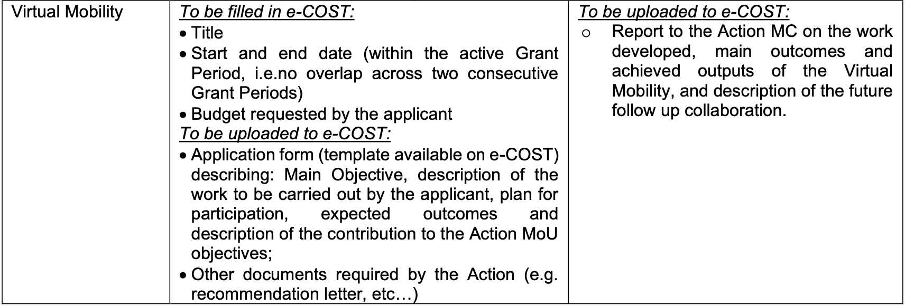

Detailed instructions on how to apply for VMG can be found in COST’s official Grant Awarding User guide available HERE.

Financial support
o A maximum of EUR 1,500 can be granted to for each successful applicant.

In case of any queries, kindly contact the GAC, XXXX

